

**Semester 04 (Fall 2024)**

**Instructor: Malik Ali Lab Engineer: Hareem Fatima**

**CSL-220: Database Management System**

**Exercises**

Now by using the student information system, formulate the following queries in SQL

1. Display the Job and maximum salary of all designations using teachers table.

Query:

select Job,max(BasicSalary) as 'MaxSalary' from Teacher group by Job

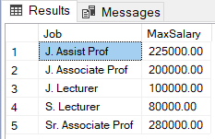

1. Display Sum and Average Salary of each job type from employees table.

Query:

select Job,sum(BasicSalary) as 'SumOfBasicSalary',avg(BasicSalary) as 'AVGBasicSalary' from Teacher group by Job

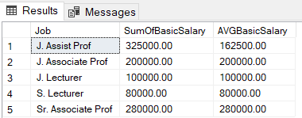

1. Display Job Titles where average salary (basic + commission) of employees is greater than 1400. Use employee table.

Query:

select Job,avg(sal + isnull(comm,0)) as 'AVGSalary' from emp group by Job having avg(sal + isnull(comm,0))>1400

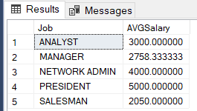

1. Display the Total Number of teachers who have no house rent.

Query:

select count(*) as 'NoHouseRent' from Teacher where HouseRent is null

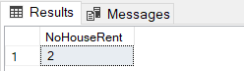

1. Select designation, maximum salary of that designation from teacher’s table where maximum salary is greater than 230 K. Show records in descending order with respect to salary.

Query:

select Job,max(BasicSalary) as 'MaxSalary' from Teacher group by Job having max(BasicSalary)>230000 order by 'MaxSalary' desc

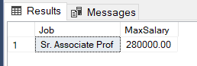

1. Write a query to display Job Title and number of faculty where job title is “J. Assist Prof”.

Query:

select Job,count(*) as NoOfEmployees from Teacher where Job like 'J. Assist Prof' group by Job

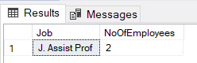

1. Write a query that displays employee names and their salaries who joined company before January 1, 1984. Format the date in the given manner and then display.

Query:

select TeacherName,BasicSalary,format(TeacherDOJ,'mmm-dd-yyyy') as NewTeacherDOJ from Teacher where TeacherDOJ < '1984-01-01' group by TeacherName,BasicSalary,TeacherDOJ



1. Write a query to display job title, number of employees and average salary (basic + commission) of all employees in that particular job title. Label columns as job title, Number of Employees, and Average Salary respectively. Round the average salary to three decimal places.

Query:

select Job as 'JobTitle',count(*) as 'NumberOfEmp', round(avg(sal),3) as 'AvgSalary' from emp group by job

